Practice Module-Kangaroo Legs Spec Sheet 10/19/13

Purpose: To describe the layout of the PM-Kangaroo Legs (KL); this practice module will teach the user how to interact with controls when they are playing as CCC-KL.

**Graphic Definitions:** This section will define general descriptions of the graphics in the layout of the module:

**Path:** This will be a group of graphics that will all move at the same rate; there are several layers of graphics within the Path. The rate this layer moves depends on the action called (see Human Spec Sheet).

**Boundaries**: These graphics will be simple lines defining the boundaries that CCC will interact with. They will be on the same layer that is occupied by the CCC graphics. These graphics will be kept transparent so that the user does not see the lines. The holes, walls, gaps, and bumps in the boundaries have been placed specifically so that specific actions (jumping) must be used to move along or around the boundary lines.

**Back Graphics:** These graphics will be contained in the layer directly beneath the Boundaries layer. These will provide visual representations of the boundary lines. It will appear that the user is interacting with these graphics. CCC will be in front of these graphics.

**Fore Graphics**: These graphics will be contained in the layer directly above the Boundaries layer. They will appear to give the game depth as CCC will move behind the objects in this layer.

**Background Graphics**: These graphics will move slower than the Path graphics, hopefully, creating a parallaxing effect. The sole purpose of these graphics is to give the game more depth. These graphics will be on a layer beneath the Path graphics; the Path will move in front of these graphics.

**Foreground Graphics**: These graphics will move faster than the Path graphics, another parallaxing effect. The sole purpose of these graphics is to give the game more depth. These graphics will be on a layer above the Path graphics; the Path will move behind these graphics.

**Sky**:This layer will contain a simple box that will serve as the sky. This layer will not move at all and will be the bottom-most layer.

**Instructions**: To teach the user how to interact with the actions associated with this CCC, sound bites, action demos, and text will appear at different trigger points. These trigger points will be a specific location along the Boundaries or objects that the user collides with. The animations will not move with respect to whatever user action is being called at that moment. **Another option** is to place transparent trigger objects at these locations; when CCC collides with an object the instructions come up.

**Layout**: The graphics associated with this layout are a little different. To make layer stacking easier there are blue cross hairs in the corners of every layer. Line up the crosshairs to correctly align the layers. This module was also designed in pieces to be assembled by you, the coders. Adobe Flash did not allow me to edit objects longer than 6000 pixels, which is a pretty small space to play in. The Path graphics were therefore split into two pieces. When the graphics are compiled the blue crosshairs in the bottom right corner of the first piece (e.g. “Boundaries-KL 1”) line up with the blue crosshairs in the bottom left corner of the second piece (e.g. “Boundaries-KL 2”). The resulting Path object should be about 12,000 pixels long. See the following figures for examples of how the layout should look.

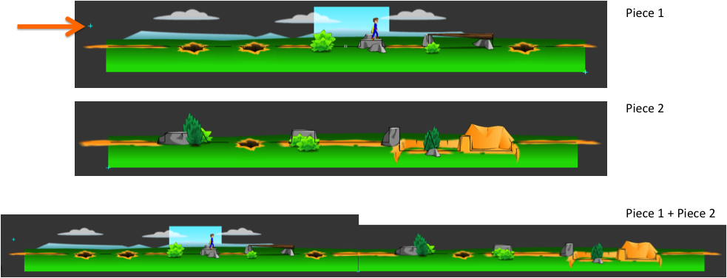

Figure 1. The top picture is of the Background Graphics, Sky and Path-Piece 1. The orange arrow is pointing to an example of the blue crosshairs used to align all of the layers. The middle picture is of the Path Piece 2. The bottom picture is both pieces lined up to make one long layout. The red arrows are indicating the crosshairs that will be aligned to add the two pieces together.



Figure 2. The map of PM-KL showing the location of instruction triggers and energy objects.